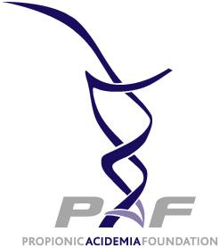

DONOR INFORMATION
Title (Dr., Ms., Mrs., or Mr.) _____
First Name ___________________ Last Name____________________
Address Line 1 _____________________
Address Line 2______________________
City_______________________ State/Province _______________
Country_____________________
Postal Code/Zip Code________________
Phone_____________________________ E-mail____________________________

We will not share your e-mail address with third parties and will only send email pertaining to news and events at PAF. Check the box to opt out of receiving e-mail updates from the Propionic Acidemia Foundation. ⁭

ENCLOSED IS MY CONTRIBUTION:
⁭$25 ⁭ $50 ⁭$100 ⁭ $250 ⁭$500 ⁭$1,000 ⁭ Other Amount $____

If applicable:
In Memory of (a donation made in memory of someone) _________________________
In Honor of (a donation made in recognition of a living person or event) _____________

I work for a matching gift company and have enclosed the necessary form for matching. ⁭ Yes ⁭ No

PLEASE SEND AN ACKNOWLEDGEMENT OF MY DONATION TO
Title (Dr., Ms., Mrs., or Mr.) _____
First Name _____________________ Last Name__________________
Address _____________________
City_______________________ State__________
Country/Province______________________ Postal Code__________________

PLEASE MAIL THIS FORM WITH YOUR CHECK MADE PAYABLE TO:
Propionic Acidemia Foundation
1963 McCraren Road
Highland Park, IL 60035

Thank you for making a difference.

